PROJECT REPORT ON

PHP

**TECHNO INDIA-BATANAGAR**

**Prepared by:**

**NILANJAN DAS**

**AND**

**MRINAL DAS**

**Branch:** Computer Science And Engineering

**Year:** 2018 ( 5TH semester)

TRAVEL AGENCY WEBSITE

IN PHP

**Prepared for:**

CSE Department

Under the guidance of: DEEPA ASHOK MAM

**Prepared by:**

Nilanjan Das, University Registration No- 163320110029 of 2016-20

Mrinal Das, University Registration No- 163320110026 of 2016-20

**Table of Contents**

Acknowledgement

Abstract

Project Scope

Requirement Specification

Database Design

Screenshots ..

Code ..

Future Scope of Improvements ..

References ………………………………………………………………………………………………………………………

Acknowledgement

I take this opportunity to express my profound gratitude and deep regards to my faculty for her exemplary guidance, monitoring and constant encouragement throughout the course of this project. The blessing, help and guidance given by her time to time shall carry me a long way in the journey of life on which I am about to embark.

I am obliged to my project team members for the valuable information provided by them in their respective fields. I am grateful for their cooperation during the period of my assignment.

(NILANJAN DAS & MRINAL DAS)

**Abstract**

In today’s increasingly connected, digitized world, travel websites and apps ease access to travel planning and booking. As speed and availability in ecommerce increase, travel bookings become easier and more convenient. So why would anyone pay a professional travel planner, when everything is available online? The increased availability has made it difficult for business travellers to compare the various offers that are available online. Corporate travellers do not have the time to scroll through web pages.

The primary project goals consist of:

According to a study by Google, the average traveller looks at five videos and undertakes 380 web page visits through 34 different searches over a period of two month. Hence, travel bookings are very time-consuming. Booking via a travel agents can certainly save time and improve the overall travel experience. Travel professionals reduce stress and time-constraints by making the corporate traveller’s journey as smooth as possible.

Bookings via travel agents can also be cheaper than bookings from several different providers as agents can create packages specifically for the corporate traveller including accommodation, flights and car rentals.

* Especially for complex travel requests, travel agents are worth a mint. They have connections to make sure everything goes well. Sometimes corporate travel has very specific needs, as business travellers must adjust to unknown and complex destinations. Travel agencies know how to find a hotel with the right conference room capacity close to the airport or the city centre. Therefore, travel agents function as a knowledge base.

* Let’s be honest, problems and disruptions are part of most journeys. From lost luggage to train or flight delays and errors in accommodation bookings, travel agents solve these challenges very fast because it is their daily business. This is extremely important for corporate travelers as they often spend very short time spans in one location and can therefore not afford complications or delays within their travel itineraries.

**Project Scope**

*(This page shall elaborate the boundary conditions of the project)*

***Project Scope – An Example***

*[The broad scope of the event veterinary doctor’s portal project includes:*

* The system will be available on an online platform for 24x7 access to the users.*

 *The system will support proper searching and booking of travel packages according to the perfect location search.*

 *The system will provide social interaction tools such as Chats, Packages etc., to enable interaction amongst users and us to get the details of their requirement.*

**Requirement Specification**

Domain Description

We used basically html, css, js, and php in our project for the front end and back end infrastructure development. As we know php is a scripting language it is moreover used for the scripting part of the website.html, js and css is used for the design and the things we wanted to include in our website. Combining css, js, php and html the total website is build.

Problem Definition

The basic idea was to solve the problem of tourists who are keen interested in travelling and exploration. Moreover they can get compact platform to solve their problem regarding any query.

Functional Requirements

With the most recent developments and changes in the business environment, data and information must be effectively gathered, managed and stored in order to keep pace and compete in the field of Travel agency. Thus, an easier and cost-efficient manner of handling information is necessary.



This user-friendly software will provide the facility of searching and finding the right place to visit in different places of the world. Moreover one a get a complete package with discounts at its affordable cost.

Hardware /Software Requirements

1. Hardware requirement
   * Client side

In client side the client needs pc with a web browser and working internet connection.

* Server side

In server side we need pc’s with working internet connection to design the website.

1. Software Requirement
   * Client side

In client side, the client needs to have a web browser.

* + Server side

Apache, phpmyadmin, mysql are used in the server side

**SCREENSHOTS:**

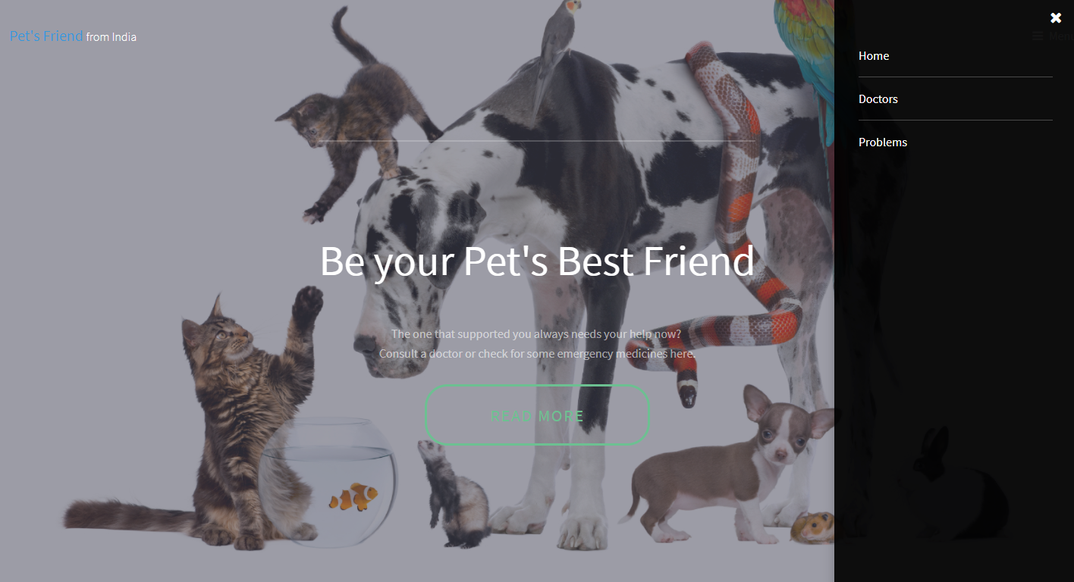

Home Page 1

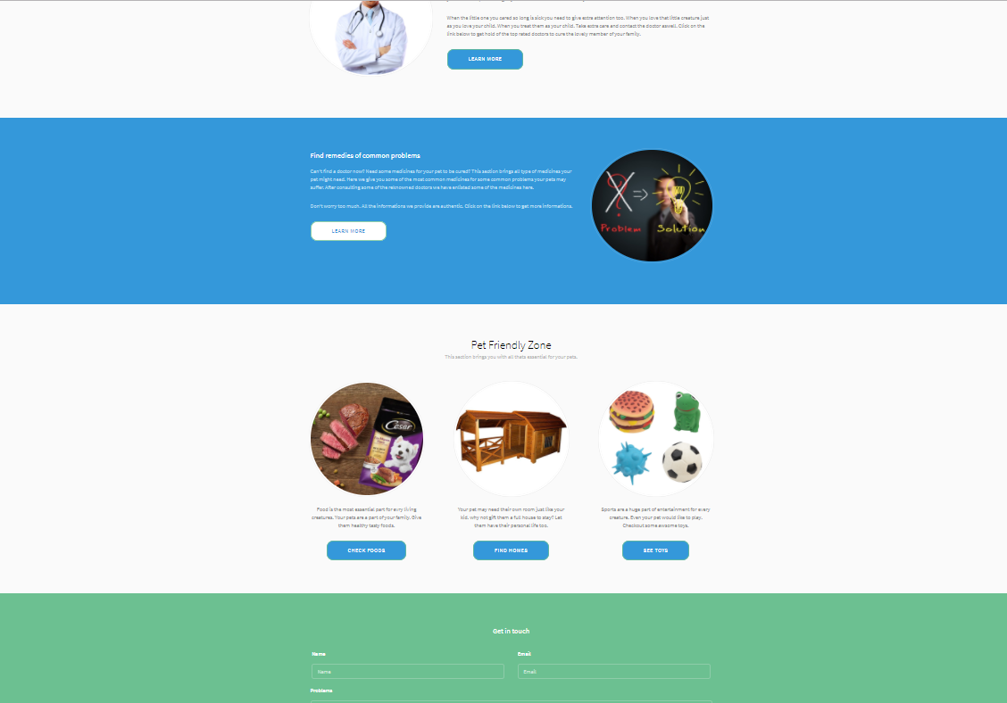

Home Page 2

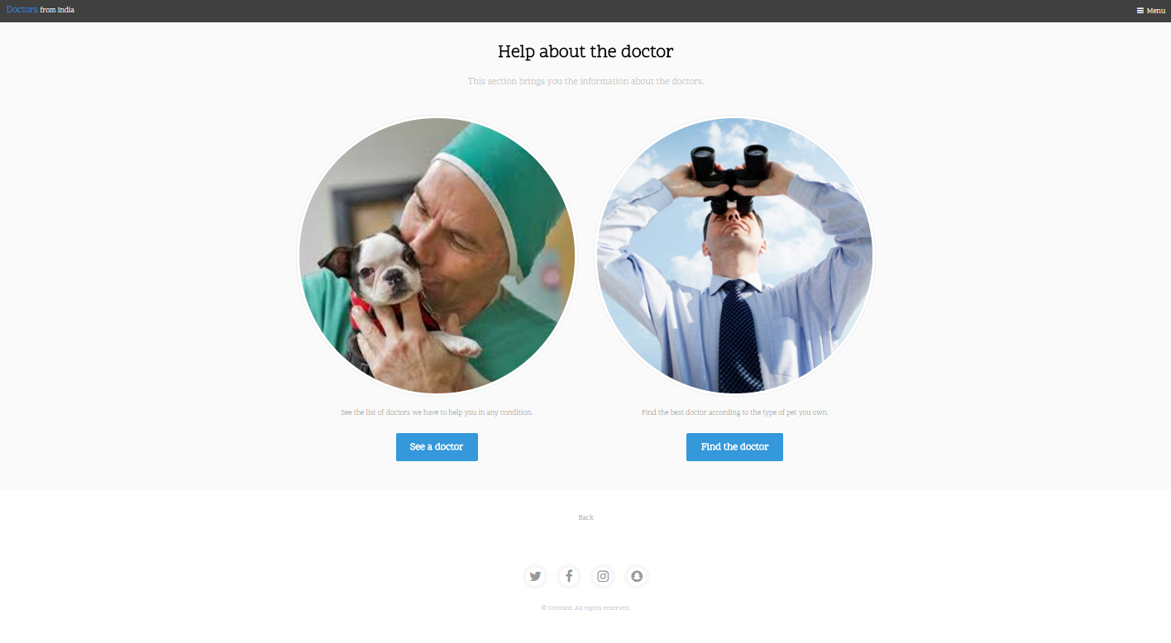

Doctors

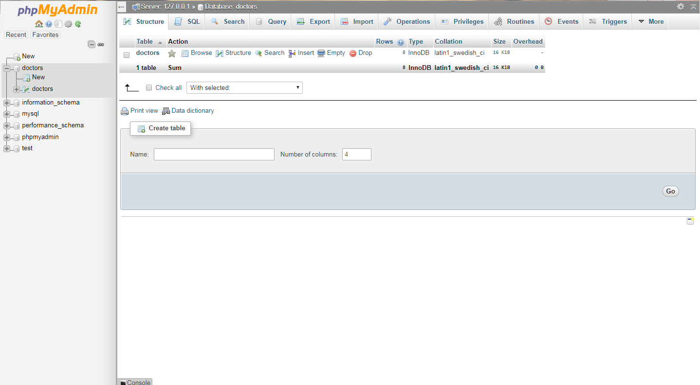

Doctors Database

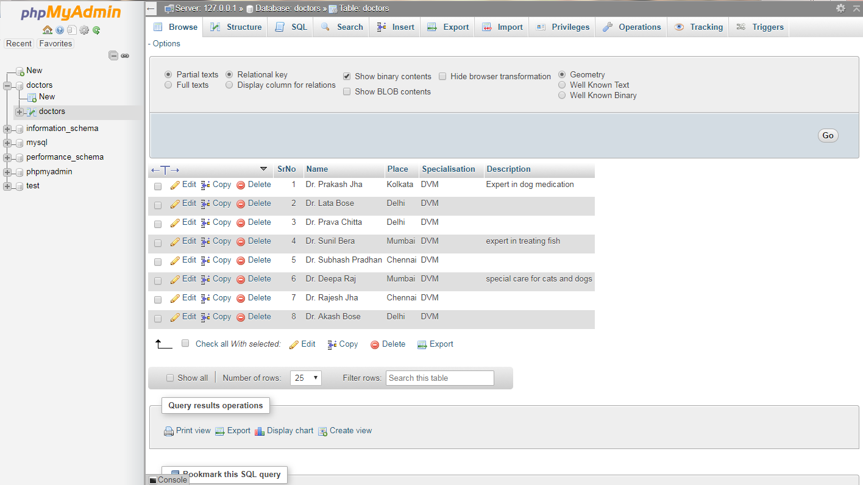

Doctors Table

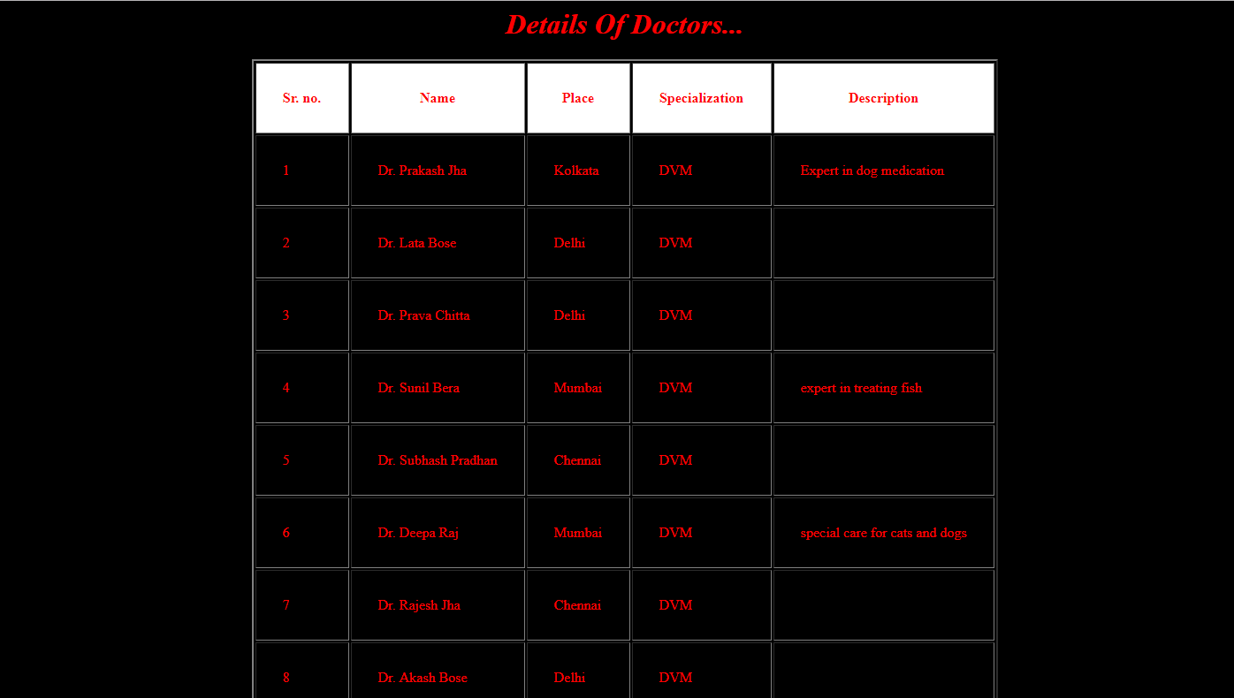

List of Doctors

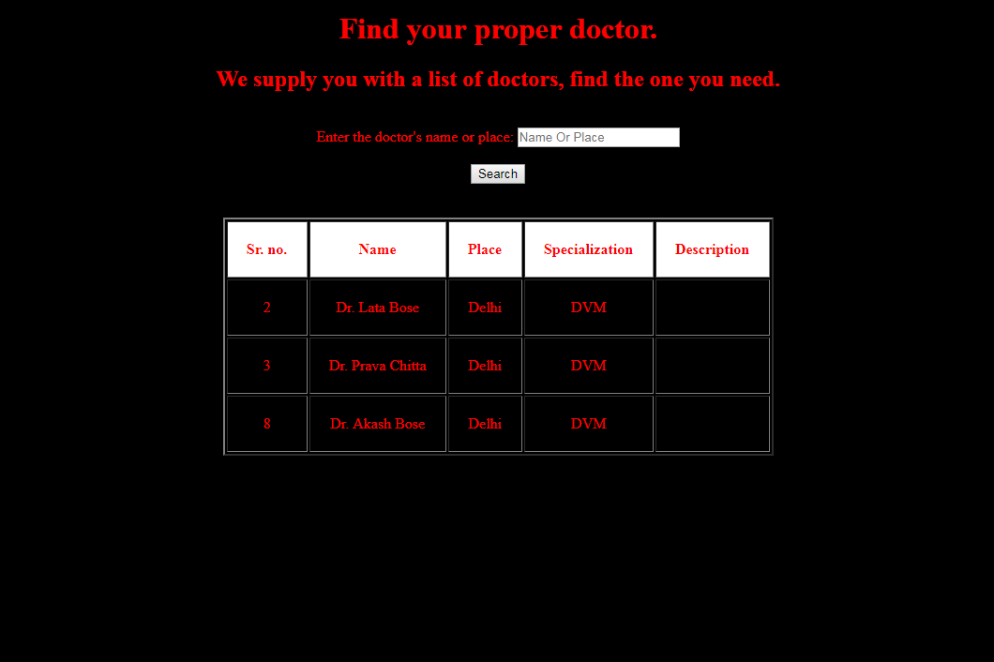

Doctors Search Result

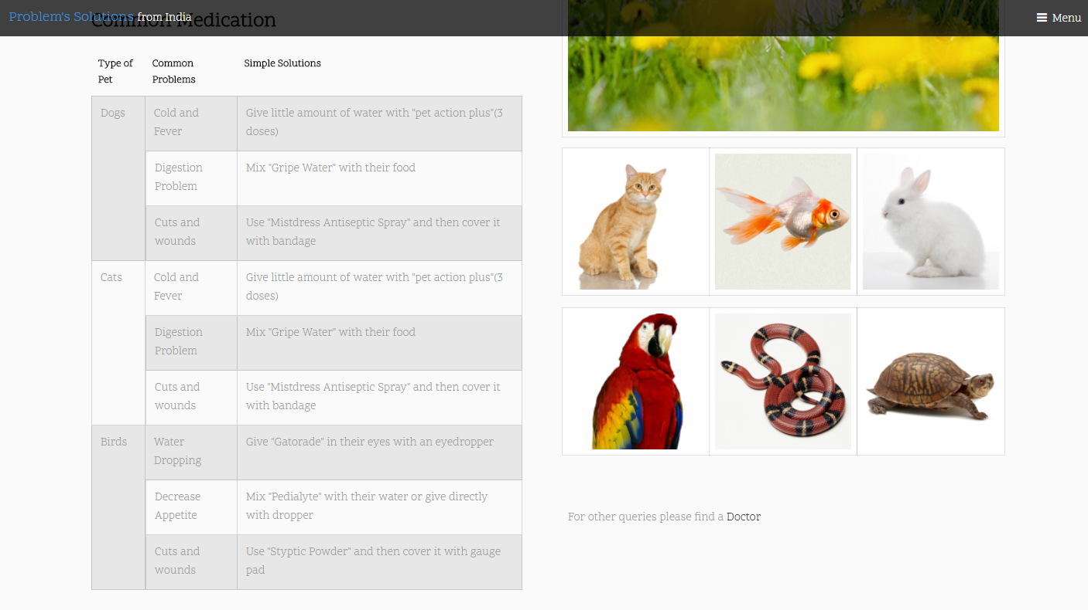

**Medication for Pets**

**CODE:**

**index.php**

<!DOCTYPE HTML>

<html>

<head>

<title>Pet's Friend</title>

<meta charset="utf-8" />

<meta name="viewport" content="width=device-width, initial-scale=1" />

<link rel="stylesheet" href="assets/css/main.css" />

<link rel="stylesheet" href="assets/css2/main.css" />

</head>

<body>

<!-- Header -->

<header id="header" class="alt">

<div class="logo">

<a href="index.php">Pet's Friend <span>from India</span></a>

</div>

<a href="#menu">Menu</a>

</header>

<!-- Nav -->

<nav id="menu">

<ul class="links">

<li><a href="index.php">Home</a></li>

<li><a href="generic.php">Doctors</a></li>

<li><a href="elements.php">Problems</a></li>

</ul>

</nav>

<!-- banner -->

<section id="banner">

<div class="inner">

<header>

<h1>Be your Pet's Best Friend</h1>

<p>The one that supported you always needs your help now?

<br />

Consult a doctor or check for some emergency medicines here.</p>

</header>

<a href="#main" class="button big scrolly">Read More</a>

</div>

</section>

<!-- Main -->

<div id="main">

<!-- Section -->

<section class="wrapper style1">

<div class="inner">

<!-- 2 Columns -->

<div class="flex flex-2">

<div class="col col1">

<div class="image round fit">

<a href="generic.php" class="link"><img src="images/image1.jpg" alt="" /></a>

</div>

</div>

<div class="col col2">

<h3>Find Your Doctor</h3>

<p>Is your pet sick? Do they need some expert help? Can't you find the doctor nearby? We are her to give you same support.

Don't panic when your little loved one sick. Try to get hold of a doctor as soon as possible. We are here to help you do so.

Keep one thing in your mind. Never ever medicate yourself.</p>

<p>When the little one you cared so long is sick you need to give extra attention too.

When you love that little creature just as you love your child.

When you treat them as your child. Take extra care and contact the doctor aswell. Click on the link below to get hold of the top rated doctors to cure the lovely member of your family. </p>

<a href="generic.php" class="button">Learn More</a>

</div>

</div>

</div>

</section>

<!-- Section -->

<section class="wrapper style2">

<div class="inner">

<div class="flex flex-2">

<div class="col col2">

<h3>Find remedies of common problems</h3>

<p>Can't find a doctor now? Need some medicines for your pet to be cured? This section brings all type of medicines your pet might need.

Here we give you some of the most common medicines for some common problems your pets may suffer. After consulting some of the reknowned

doctors we have enlisted some of the medicines here.</p>

<p>Don't worry too much. All the informations we provide are authentic. Click on the link below to get more informations.</p>

<a href="elements.php" class="button">Learn More</a>

</div>

<div class="col col1 first">

<div class="image round fit">

<a href="generic.php" class="link"><img src="images/image2.jpg" alt="" /></a>

</div>

</div>

</div>

</div>

</section>

<!-- Section -->

<section class="wrapper style1">

<div class="inner">

<header class="align-center">

<h2>Pet Friendly Zone</h2>

<p>This section brings you with all thats essential for your pets.</p>

</header>

<div class="flex flex-3">

<div class="col align-center">

<div class="image round fit">

<img src="images/image3.jpg" alt="" />

</div>

<p>Food is the most essential part for evry living creatures. Your pets are a part of your family. Give them healthy tasty foods.</p>

<a href="https://www.dogspot.in/" class="button">Check Foods</a>

</div>

<div class="col align-center">

<div class="image round fit">

<img src="images/image4.jpg" alt="" />

</div>

<p>Your pet may need their own room just like your kid. why not gift them a full house to stay? Let them have their personal life too.</p>

<a href="https://www.dogspot.in/" class="button">Find Homes</a>

</div>

<div class="col align-center">

<div class="image round fit">

<img src="images/image5.jpg" alt="" />

</div>

<p>Sports are a huge part of entertainment for every creature. Even your pet would like to play. Checkout some awsome toys.</p>

<a href="https://www.dogspot.in/" class="button">See Toys</a>

</div>

</div>

</div>

</section>

</div>

<!-- Footer -->

<footer id="footer">

<div class="inner">

<h3>Get in touch</h3>

<form action="#" method="post">

<div class="field half first">

<label for="name">Name</label>

<input name="name" id="name" type="text" placeholder="Name">

</div>

<div class="field half">

<label for="email">Email</label>

<input name="email" id="email" type="email" placeholder="Email">

</div>

<div class="field">

<label for="message">Problems</label>

<textarea name="message" id="message" rows="6" placeholder="Message"></textarea>

</div>

<ul class="actions">

<li><input value="Send Message" class="button alt" type="submit"></li>

</ul>

</form>

</div>

<div class="copyright">

<ul class="icons">

<li><a href="https://twitter.com/login" class="icon fa-twitter"><span class="label">Twitter</span></a></li>

<li><a href="https://www.facebook.com/login" class="icon fa-facebook"><span class="label">Facebook</span></a></li>

<li><a href="https://www.instagram.com/accounts/login/" class="icon fa-instagram"><span class="label">Instagram</span></a></li>

<li><a href="https://accounts.snapchat.com/accounts/login" class="icon fa-snapchat"><span class="label">Snapchat</span></a></li>

</ul>

<p>&copy; Untitled. All rights reserved.</p>

</div>

</footer>

<!-- Scripts -->

<script src="assets/js/jquery.min.js"></script>

<script src="assets/js/jquery.scrolly.min.js"></script>

<script src="assets/js/jquery.scrollex.min.js"></script>

<script src="assets/js/skel.min.js"></script>

<script src="assets/js/util.js"></script>

<script src="assets/js/main.js"></script>

<!-- Scripts -->

<script src="assets/js2/jquery.min.js"></script>

<script src="assets/js2/skel.min.js"></script>

<script src="assets/js2/util.js"></script>

<script src="assets/js2/main.js"></script>

</body>

</html>

**generic.php**

<!DOCTYPE HTML>

<html>

<head>

<title>Doctor's Help</title>

<meta charset="utf-8" />

<meta name="viewport" content="width=device-width, initial-scale=1" />

<link rel="stylesheet" href="assets/css/main.css" />

</head>

<body class="subpage">

<!-- Header -->

<header id="header">

<div class="logo"><a href="index.php">Doctors <span>from India</span></a></div>

<a href="#menu">Menu</a>

</header>

<!-- Nav -->

<nav id="menu">

<ul class="links">

<li><a href="index.php">Home</a></li>

<li><a href="generic.php">Doctors</a></li>

<li><a href="elements.php">Problems</a></li>

</ul>

</nav>

<!-- Main -->

<div id="main">

<!-- Section -->

<section class="wrapper">

<div class="inner">

<header class="align-center">

<h1>Doctors</h1>

<p>Doctors are the most important part in anyone's life, so in your pet's life too.</p>

</header>

<div class="flex flex-2">

<div class="col col2">

<h3>Doctors. The savior of life.</h3>

<p>Whenever there is any problem, whenever there is any need, there is always a person who is

always ready. Some treat them as God's friend while someone thinks them to be the God himself.

Why won't anyone do that? They always help people at any situation. They never say NO.

We keep an eye on them in every little pain, in every minor condition. They are the only person

we depend on throughout our lives. So, does our little family members.</p>

<p>Why to let our little members tolerate pain when there is a way to cure them. Those little buddies

can't express themselves and thus stay abandoned most of the time. It is the duty of the human beings to protect their loved ones.

When you consider your pets to be a part of your family, you must also be responsible

for their health. Every doctor has taken the voe to help you in your need. You must take the vow to protect your members too. The one you love must always be under your protective arms. The pets you own must be

one you love, or else why would you have them? Keep them safe, keep them loving.</p>

</div>

<div class="col col1 first">

<div class="image round fit">

<a href="generic.php" class="link"><img src="images/image1.jpg" alt="" /></a>

</div>

</div>

</div>

</div>

</section>

<!-- Section -->

<section class="wrapper style1">

<div class="inner">

<header class="align-center">

<h2>Help about the doctor</h2>

<p>This section brings you the information about the doctors.</p>

</header>

<div class="flex flex-2">

<div class="col align-center">

<div class="image round fit">

<img src="images/image7.jpg" alt="" />

</div>

<p>See the list of doctors we have to help you in any condition.</p>

<a href="doctors.php" class="button big">See a doctor</a>

</div>

<div class="col align-center">

<div class="image round fit">

<img src="images/image6.jpg" alt="" />

</div>

<p>Find the best doctor according to the type of pet you own.</p>

<a href="search.php" class="button big">Find the doctor</a>

</div>

</div>

</div>

</section>

</div>

<center>

<br>

<br>

<a href="index.php">Back</a>

</center>

<!-- Footer -->

<footer id="footer">

<div class="copyright">

<ul class="icons">

<li><a href="https://twitter.com/login" class="icon fa-twitter"><span class="label">Twitter</span></a></li>

<li><a href="https://www.facebook.com/login" class="icon fa-facebook"><span class="label">Facebook</span></a></li>

<li><a href="https://www.instagram.com/accounts/login/" class="icon fa-instagram"><span class="label">Instagram</span></a></li>

<li><a href="https://accounts.snapchat.com/accounts/login" class="icon fa-snapchat"><span class="label">Snapchat</span></a></li>

</ul>

<p>&copy; Untitled. All rights reserved.</p>

</div>

</footer>

<!-- Scripts -->

<script src="assets/js/jquery.min.js"></script>

<script src="assets/js/jquery.scrolly.min.js"></script>

<script src="assets/js/jquery.scrollex.min.js"></script>

<script src="assets/js/skel.min.js"></script>

<script src="assets/js/util.js"></script>

<script src="assets/js/main.js"></script>

</body>

</html>

**elements.php**

<!DOCTYPE HTML>

<html>

<head>

<meta charset="utf-8" />

<meta name="viewport" content="width=device-width, initial-scale=1" />

<link rel="stylesheet" href="assets/css/main.css" />

</head>

<body class="subpage">

<!-- Header -->

<header id="header">

<div class="logo">

<a href="index.php">Problem's Solutions <span>from

India</span></a>

</div>

<a href="#menu">Menu</a>

</header>

<!-- Nav -->

<nav id="menu">

<ul class="links">

<li><a href="index.php">Home</a></li>

<li><a href="generic.php">Doctors</a></li>

<li><a href="elements.php">Problems</a></li>

</ul>

</nav>

<!-- Main -->

<div id="main">

<section class="wrapper style1">

<div class="inner">

<header class="align-center">

<h1>Problems</h1>

<p>Every problem has a solution. Find your's here.</p>

</header>

<!-- Content -->

<h2 id="content">Major Problems of Pets</h2>

<p>Pets can't express their feelings. The major problem your lovely pets face. Since they can't speak,

they can't tell you what they feel. It's your responsibility to understand their need. It's your responsibility

to take care of them. Pets also face a problem of neglecting

their problems, since most of them don't

want to trouble their masters. It's your responsibility to understand their problems and take steps. Pets can

also face digestion problems. They lack their proper eating habbits which lead to such problems.</p>

<div class="row">

<!-- Break -->

<div class="4u 12u$(medium)">

<h3>How to understand?</h3>

<p>If your pet is not behaving usual, if they are feeling weak, they are no more energetic then

they may be sick. Find out if they are too reluctant about their daily activities, if they are more

prone to sleepiness than being active. Take a closure look at them.</p>

</div>

<div class="4u 12u$(medium)">

<h3>What to do then?</h3>

<p>Take actions, give them the required treatment they need. Medicate them if required, but don't

if you have no idea how to. Always try to consult a doctor for every little bit of problems

your little family member faces. It will keep

them safe.</p>

</div>

<div class="4u$ 12u$(medium)">

<h3>How to react?</h3>

<p>Don't ever panic. This leads to major problems. Keep yourself calm so that you can keep your pet

calm aswell. Then call a doctor or take them to the nearest hospital. Pamper them well. They need that

more when they are sick. They crave for the motherly love.</p>

</div>

</div>

<hr class="major" />

<!-- Elements -->

<h2 id="elements">Cure with Care</h2>

<div class="row 200%">

<div class="6u 12u$(medium)">

<!-- Text stuff -->

<h3>Care is the most important part for cure</h3>

<p>Why should you take <b>care</b> of your pets? Why do they need your <b>care</b>?

Help them get your care. Your care is the foremost thing they need to be cured soon.</p>

<hr />

<h3>Your Pet</h3>

<h3>Your Family</h3>

<h3>Your Responsibility</h3>

<h3>Your Care, Their Cure</h3>

<hr />

<!-- Table -->

<h3>Common Medication</h3>

<div class="table-wrapper">

<table class="alt">

<thead>

<tr>

<th>Type of Pet</th>

<th>Common Problems</th>

<th>Simple Solutions</th>

</tr>

</thead>

<tbody>

<tr>

<td rowspan="3">Dogs</td>

<td>Cold and Fever</td>

<td>Give little amount of water with "pet action plus"(3 doses)</td>

</tr>

<tr>

<td>Digestion Problem</td>

<td>Mix "Gripe Water" with their food</td>

</tr>

<tr>

<td>Cuts and wounds</td>

<td>Use "Mistdress Antiseptic Spray" and then cover it with bandage</td>

</tr>

<tr>

<td rowspan="3">Cats</td>

<td>Cold and Fever</td>

<td>Give little amount of water with "pet action plus"(3 doses)</td>

</tr>

<tr>

<td>Digestion Problem</td>

<td>Mix "Gripe Water" with their food</td>

</tr>

<tr>

<td>Cuts and wounds</td>

<td>Use "Mistdress Antiseptic Spray" and then cover it with bandage</td>

</tr>

<tr>

<td rowspan="3">Birds</td>

<td>Water Dropping</td>

<td>Give "Gatorade" in their eyes with an eyedropper</td>

</tr>

<tr>

<td>Decrease Appetite</td>

<td>Mix "Pedialyte" with their water or give directly with dropper</td>

</tr>

<tr>

<td>Cuts and wounds</td>

<td>Use "Styptic Powder" and then cover it with gauge pad</td>

</tr>

</tbody>

</table>

</div>

</div>

<div class="6u$ 12u$(medium)">

<!-- Image -->

<h3>Images</h3>

<span class="image fit"><img src="images/image8.jpg" alt="" /></span>

<div class="box alt">

<div class="row 50% uniform">

<div class="4u"><span class="image fit"><img src="images/image9.jpg" alt="" /></span></div>

<div class="4u"><span class="image fit"><img src="images/image10.jpg" alt="" /></span></div>

<div class="4u$"><span class="image fit"><img src="images/image11.jpg" alt="" /></span></div>

</div>

</div>

<div class="box alt">

<div class="row 50% uniform">

<div class="4u"><span class="image fit"><img src="images/image12.jpg" alt="" /></span></div>

<div class="4u"><span class="image fit"><img src="images/image13.jpg" alt="" /></span></div>

<div class="4u$"><span class="image fit"><img src="images/image14.jpg" alt="" /></span></div>

</div>

</div>

<br>

<br>

<p>For other queries please find a <a href="generic.php">Doctor</a></p>

</div>

</div>

</div>

</section>

</div>

<center>

<br>

<br>

<a href="index.php">Back</a>

</center>

<!-- Footer -->

<footer id="footer">

<div class="copyright">

<ul class="icons">

<li><a href="https://twitter.com/login" class="icon fa-twitter"><span class="label">Twitter</span></a></li>

<li><a href="https://www.facebook.com/login" class="icon fa-facebook"><span class="label">Facebook</span></a></li>

<li><a href="https://www.instagram.com/accounts/login/" class="icon fa-instagram"><span class="label">Instagram</span></a></li>

<li><a href="https://accounts.snapchat.com/accounts/login" class="icon fa-snapchat"><span class="label">Snapchat</span></a></li>

</ul>

<p>&copy; Untitled. All rights reserved.</p>

</div>

</footer>

<!-- Scripts -->

<script src="assets/js/jquery.min.js"></script>

<script src="assets/js/jquery.scrolly.min.js"></script>

<script src="assets/js/jquery.scrollex.min.js"></script>

<script src="assets/js/skel.min.js"></script>

<script src="assets/js/util.js"></script>

<script src="assets/js/main.js"></script>

</body>

</html>

**doctors.php**

<html>

<head>

<style>

body

{

background-color:black;color:red;text-decoration:none;font-style:italic;text-align:center;

{

h1,h2

{

color:cyan;

text-align:center;

}

center

{

color:cyan;text-decoration:none;font-size:30px0px;

}

a:hover

{

background-color:green;

}

}

}

</style>

</head>

<body>

<h1>Details Of Doctors...</h1>

<?php

$con=mysqli_connect("localhost","root","","doctors");

if(!$con)

die("Cannot connect to server");

else

{

$sql="select * from doctors";

$rs=mysqli_query($con,$sql);

echo "<table border=2 align=center cellpadding=30px><tr

bgcolor=white><th>Sr. no.</th><th>Name</th><th>Place</th><th>Specialization</th><th>Description</th></tr>";

while($row=mysqli_fetch_array($rs))

{

echo "<tr bgcolor:cyan>";

echo "<td>$row[0]</td><td>$row[1]</td><td>$row[2]</td><td>$row[3]</td><td>$row[4]</td>";

echo "</tr>";

}

echo "</table>";

}

?>

<center>

<br>

<br>

<a href="generic.php">Back</a>

</center>

</body>

</html>

**search.php**

<?php

if(isset($_POST["search"]))

{

$NameOrPlace = $_POST['NameOrPlace'];

$sql = "SELECT * FROM `doctors` WHERE CONCAT(`Name`, `Place`)LIKE '%" .$NameOrPlace."%'";

$search_rs = searchTable($sql);

}

else

{

$sql = "SELECT * FROM `doctors`";

$search_rs = searchTable($sql);

}

function searchTable($sql)

{

$con = mysqli_connect("localhost","root","","doctors");

$rs = mysqli_query($con,$sql);

return $rs;

}

?>

<html>

<head>

<style>

body

{

background-color:black;color:red;text-align:center;

{

h1,h2

{

color:cyan;

text-align:center;

}

Center

{

color:cyan;text-decoration:none;font-size:30px0px;

}

a:hover

{

background-color:green;

}

}

}

</style>

</head>

<body>

<h1>Find your proper doctor.</h1>

<h2>We supply you with a list of doctors, find the one you need.</h2>

<br>

<form method="post" action="#">

<label>Enter the doctor's name or place: </label>

<input type="text" name="NameOrPlace" placeholder="Name Or Place"><br><br>

<input type="submit" name="search" value="Search"><br><br>

<br>

<?php echo "<table border=2 align=center cellpadding=20><tr bgcolor=white>

<th>Sr. no.</th><th>Name</th><th>Place</th><th>Specialization</th><th>Description</th></tr>";?>

<?php while($row = mysqli_fetch_array($search_rs)):?>

<tr>

<td><?php echo $row['SrNo'];?></td>

<td><?php echo $row['Name'];?></td>

<td><?php echo $row['Place'];?></td>

<td><?php echo $row['Specialisation'];?></td>

<td><?php echo $row['Description'];?></td>

</tr>

<?php endwhile;?>

</form>

</body>

</html>

**Future Scope of Improvements:**

In a nutshell, it can be summarised that the future scope of the project circles around maintaining information regarding:

* We can add printer in future.
* We can give more advance software for travel agency including more facilities.
* We will host the platform on online servers to make it accessible worldwide.
* Integrate multiple load balancers to distribute the loads of the system.
* Create the Admin and User database structure to reduce the overload of the database queries.
* Implement the backup mechanism for taking backup of code base.

The above mentioned points are the enhancements which can be done to increase the applicability and usage of this project. Here we can maintain the records of travel agency and customer. Also. as it can be seen that now a days the customers are versatile i.e. so there is a scope for introducing a method to maintain the travel agency. Enhancement can be done to maintain all the travel agency, customer, flights, trains, hotels, cabs, tour bookings, charges.

We have left all the options open so that if there are any other future requirements in the system by the user for the enhancement of the system then it is possible to implement them. In the last week we would like to thanks all the persons involved in the development of the system. We hope that the project will serve its purpose for which it is developed.

**References**

* www.php.net-the PHP manual and official documentation site
* [www.google.com](http://www.google.com)
* [www.w3schools.com](http://www.w3schools.com)
* [www.w3layout.com](http://www.w3layout.com)
* [www.cololib.com](http://www.cololib.com)
* [www.youtube.com](http://www.youtube.com)
* [www.wix.com](http://www.wix.com)